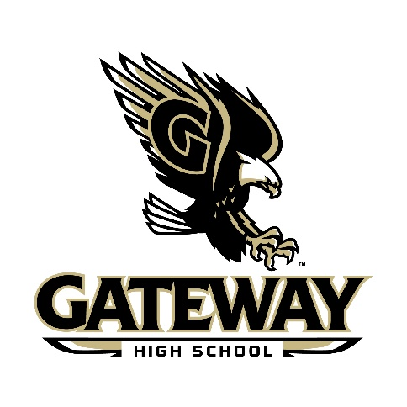
Gateway High School
SAC Agenda
October 6, 2020

- Meeting Call to Order / Determination of a Quorum
- Adoption of Agenda
- Introduction & Welcome
- School Vision/Mission
- New Business
- Student Data
- School Goals
- Election of Officers
- SAC Chair, SAC Chair Alternate, Secretary
- DAC Chair, DAC Chair Alternate
- Approval of 20-21 SAC Dates
  - November 10
  - December 1
  - January 12
  - February 2
  - March 2
  - April 6
  - May 4
- Open Agenda
- Next Meeting Confirmation / Adjournment

